Redcar Cricket Club

Description: The local Cricket club for the town with facilities for all ages in the area. Bar and function room also available.
Location: 30 Kirkleatham Street TS10 1QH
Contact: 01642 483791

Redcar Athletic Football Club
Description: One of the two football clubs in Redcar, provides a wide range of teams for all ages with excellent facilities.
Location: Mackinlay Park Green Lane TS10 3WR
Contact: 0785493580
Redcar Rugby Club
Description: The local Rugby club located next to the Squash club and over the road from Redcar athletic FC, providing a range of teams for most ages.
Location: Mackinlay Park Green Lane TS10 3RW
Contact: 01642 483791
Redcar Town Football Club
Description: One of the two football clubs in Redcar, provides a wide range of teams for all ages with excellent facilities.
Location: Trunk Road Mo Mowlam Memorial Park, Redcar TS10 5BW
Contact: 07879023233

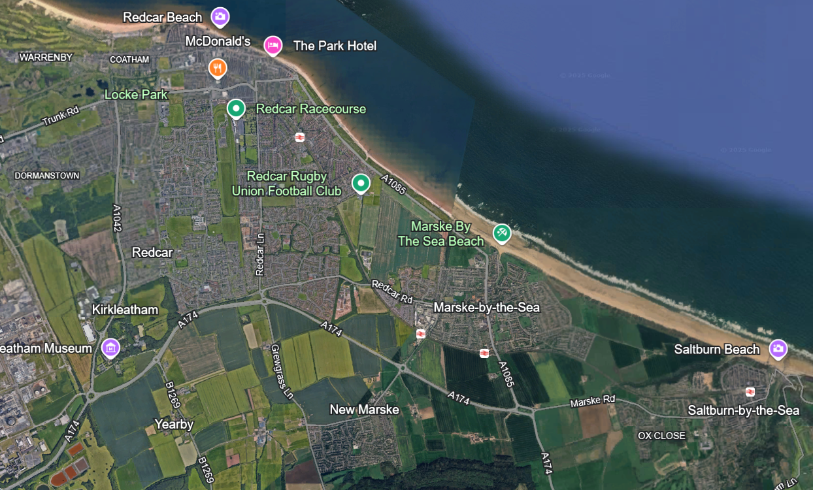

Redcar Amateur Boxing Club
Description: The Local boxing club for the surrounding area, situated close to the town centre.
Location: 5 Coatham Road, Redcar TS10 1RH
Contact: 01642 483263
Marske United Football Club
Description: The local football club for the Marske area, provides excellent facilities for a wide range of age groups.
Location: Mount Pleasant Avenue, Marske-by-the-sea, Redcar TS11 7BW
Contact: 07733040008

Cleveland School Sport Partnership
Description: Works with schools and families to promote active lives through PE, School Sport & Physical Activity. Provides opportunities for children to be active in and out of the classroom with competitions and festivals, and helping schools create active classrooms and deliver high quality PE lessons. Also provides holiday activities for children.

Location: Based at Chaloner Primary School, Guisborough. TS14 6JA

Opening Hours: 08:30 – 18:00

Contact: Andy Tennyson
Email: andy.tennyson@clevelandssp.co.uk
FB: Cleveland School Sport Partnership

Guisborough Swim and Fitness Centre
Description: The Everyone Active gym with a 25m pool and Fitness suite, fitted with large choice of cardio machines and resistance machines.
Location: Howlbeck road, Guisborough TS14 6LE
Contact: 01287 633311
Guisborough KGV Bowls Club
Description: A local bowls green located beside the King George V playing field and tennis courts.
Location: King George V Playing field, Howlbeck Road TS14 6LE
Contact: 01287 632869
Guisborough Town Football Club
Description: The local Football club for Guisborough, providing football facilities for a wide range of age groups. With many teams for all ages, qualified coaches and training.
Location: King George V Stadium, Howlbeck Road, Guisborough TS14 6LE
Contact: 01287 636925
Guisborough Tennis Club
Description: The local Tennis courts for Guisborough, with three courts and a club house. Within the area of the bowls club, Guisborough Town fc and the everyone active swimming baths.
Location: King George V Playing fields, Howlbeck Road Guisborough TS14 6LE
Contact: 01287 750030

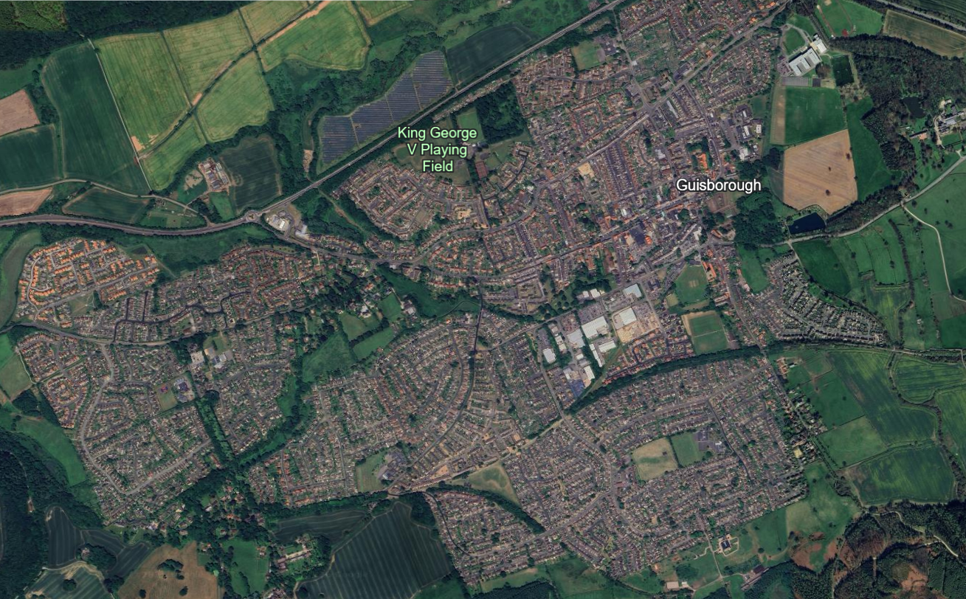

Guisborough Priory Bowls Club
Description: A local bowls green located next to the cricket club just off Rectory Lane. With Private parking.
Location: Guisborough Priory Bowls club, Fountains close TS14 7JA
Contact: 07496054340

Guisborough Cricket club
Description: The local cricket club for Guisborough, providing cricket facilities for a range of ages. A lounge bar and Function room available for use.
Location: Rectory lane, Guisborough, TS14 7DQ
Contact: Guisborough Cricket club 01287 634823

Guisborough Rugby Union Football Club
Description: The local rugby club for Guisborough and surrounding areas, providing teams from under 6’s to under 18 colts teams. With 2 Senior Men’s teams and newly 3 girls/women teams, U12 girls, U14 girls and a Senior Ladies team.
Location: Belmangate, Guisborough TS14 7BB
Opening hours: Mon-Fri – 17:00-22:00 Sat-Sun – 09:00-21:00
Contact: Lorraine Thompson
Phone number: 01287 632966

TNT Fitness Gym
Description: One of the local gyms in Guisborough with two floors of equipment ranging from cardio machines, resistance machines and a plethora of free weights. Two large studios for classes, an Ice bath, Sauna and massage rooms to book.
Location: Belmont House, Rectory Lane Guisborough TS147DJ
Opening Hours:
Mon – Thur-06:00am - 09:00pm
Frid-06:00am - 08:00pm
Sat-08:00am - 04:00pm
Sun-09:00 am - 04:00pm
Contact: contact@tnt-fitness.com 01287634439

Skelton united Football Club
Description: A local football club in the Skelton area, with a wide range of teams spanning over all ages.
Location: Marske Lane, Skelton-in-Cleveland, Saltburn-by-the-sea, TS12 2HA
Contact: 07134620723
Skelton Castle Cricket Club
Description: A local cricket club close to the historical Skelton Castle grounds, with a lovely green pavilion tucked away off the Skelton bypass.
Location: Skelton Castle Cricket Club, Saltburn-by-the-Sea TS12 2HB
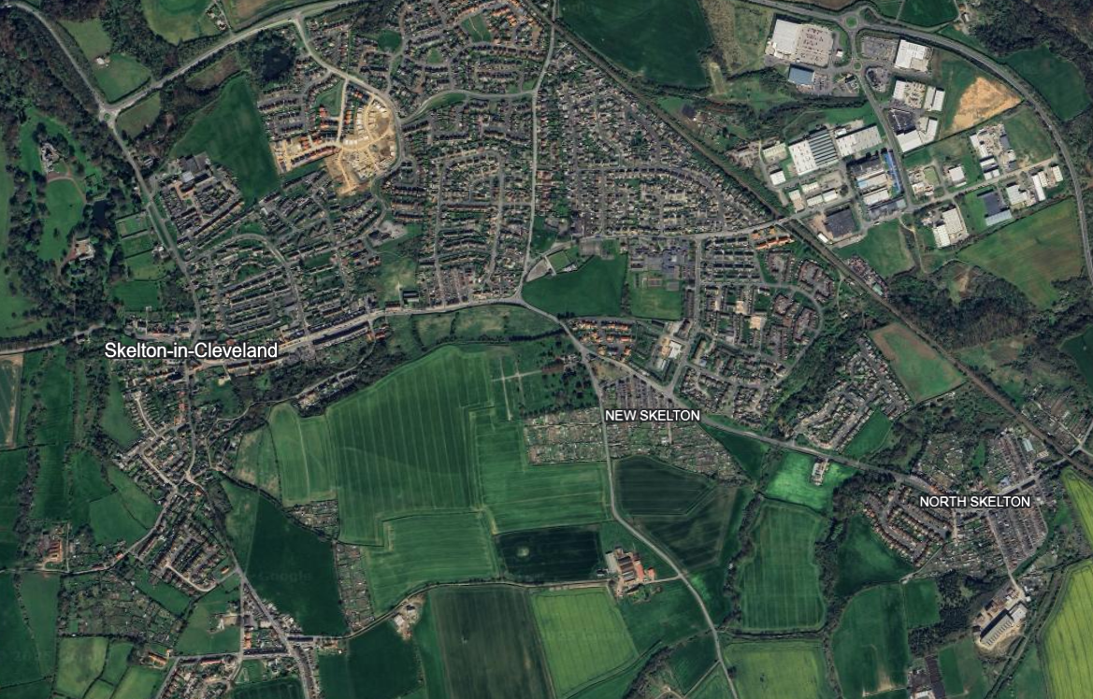
East Cleveland Basketball Club
Description: The local Basketball club for the east Cleveland area, offering a wide range of teams for all ages. Located just off Marske Lane.
Location: Marske Lane, Skelton-in-Cleveland, Saltburn-by-the-sea TS12 2HA
Contact: eastclevelandbasketball@gmail.com

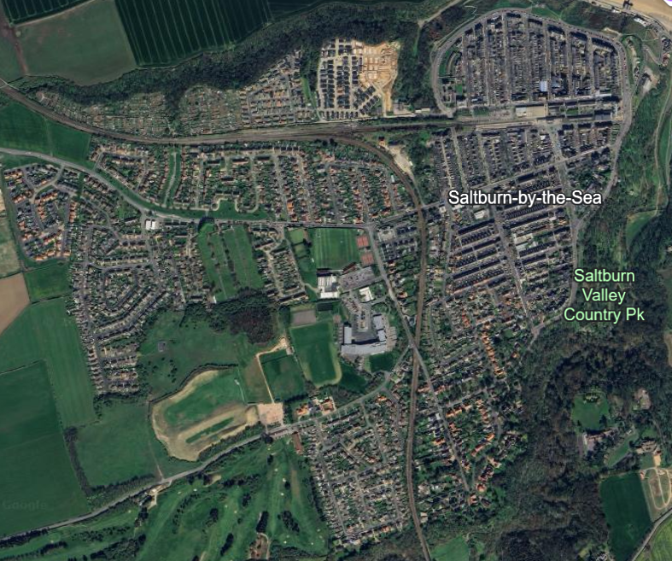
Saltburn Leisure Centre
Description: Large facility with a full sports hall, swimming pool and Gym. With changing facilities for the gym and swimming pool.
Location: Marske Mill Lane, Saltburn-by-the-sea TS12 1HJ
Contact: everyoneactive.com
Saltburn Tennis Club
Description: 4 tennis courts with small changing facilities, located right next to the cricket club.
Location: 3 Marske Mill Lane, Saltburn-by-the-sea TS12 1HJ
Contact: clubspark.lta.org.uk/SaltburnTennisClub
Saltburn Athletic Junior football club
Description: The local Football Club that offers a wide range of teams for all ages and on to senior levels.
Location: Hobs Hill, Saltburn-by-the-sea, Cleveland, TS12 1NJ
Contact: saltburnafcjuniors@outlook.com
Saltburn Cricket Club
Description: A large cricket pavilion nestled in amongst the surrounding neighbourhood. Right next to Huntcliffe Secondary School and Saltburn Leisure centre.
Location: Marske Mill Lane, Saltburn-by-the-sea TS12 1HJ
Contact: 01287 622761

